Macroeconomics Term II Project
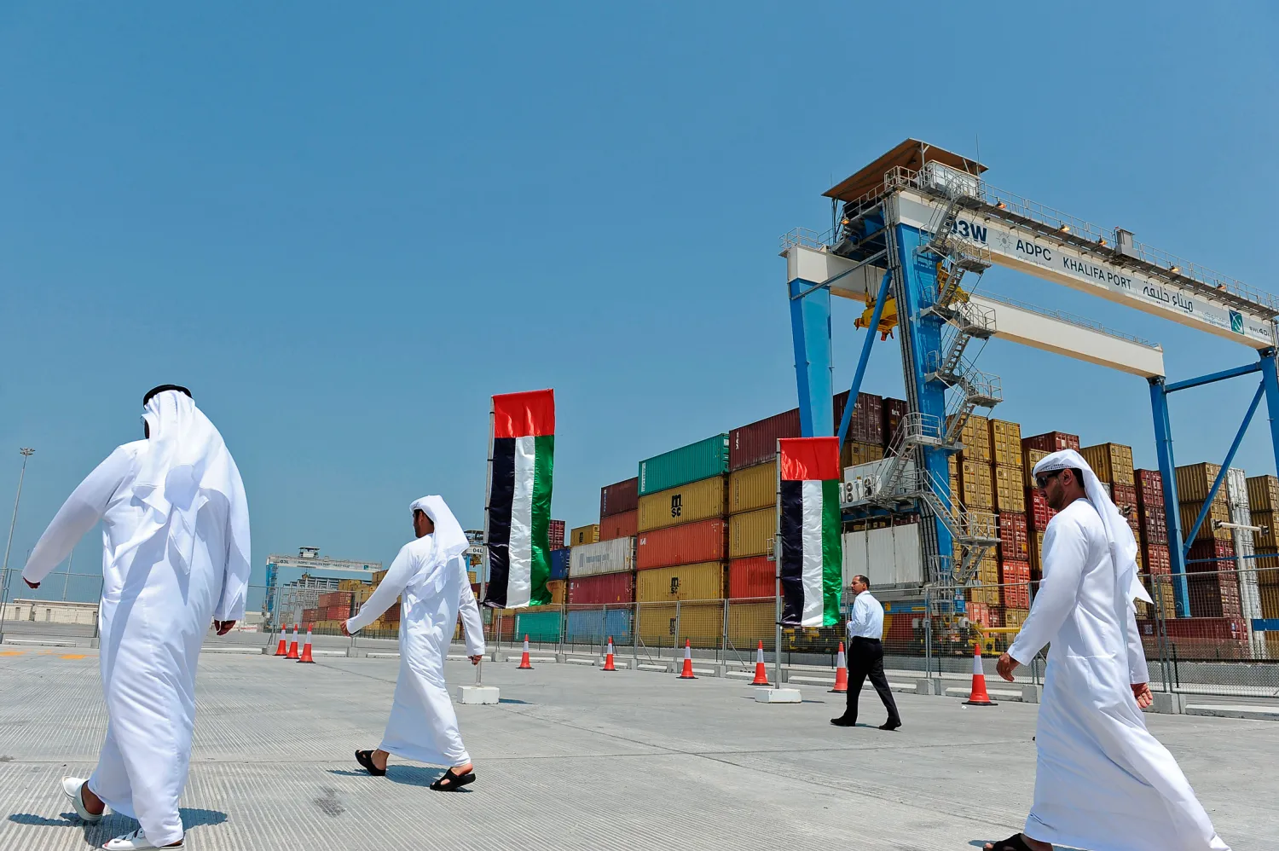
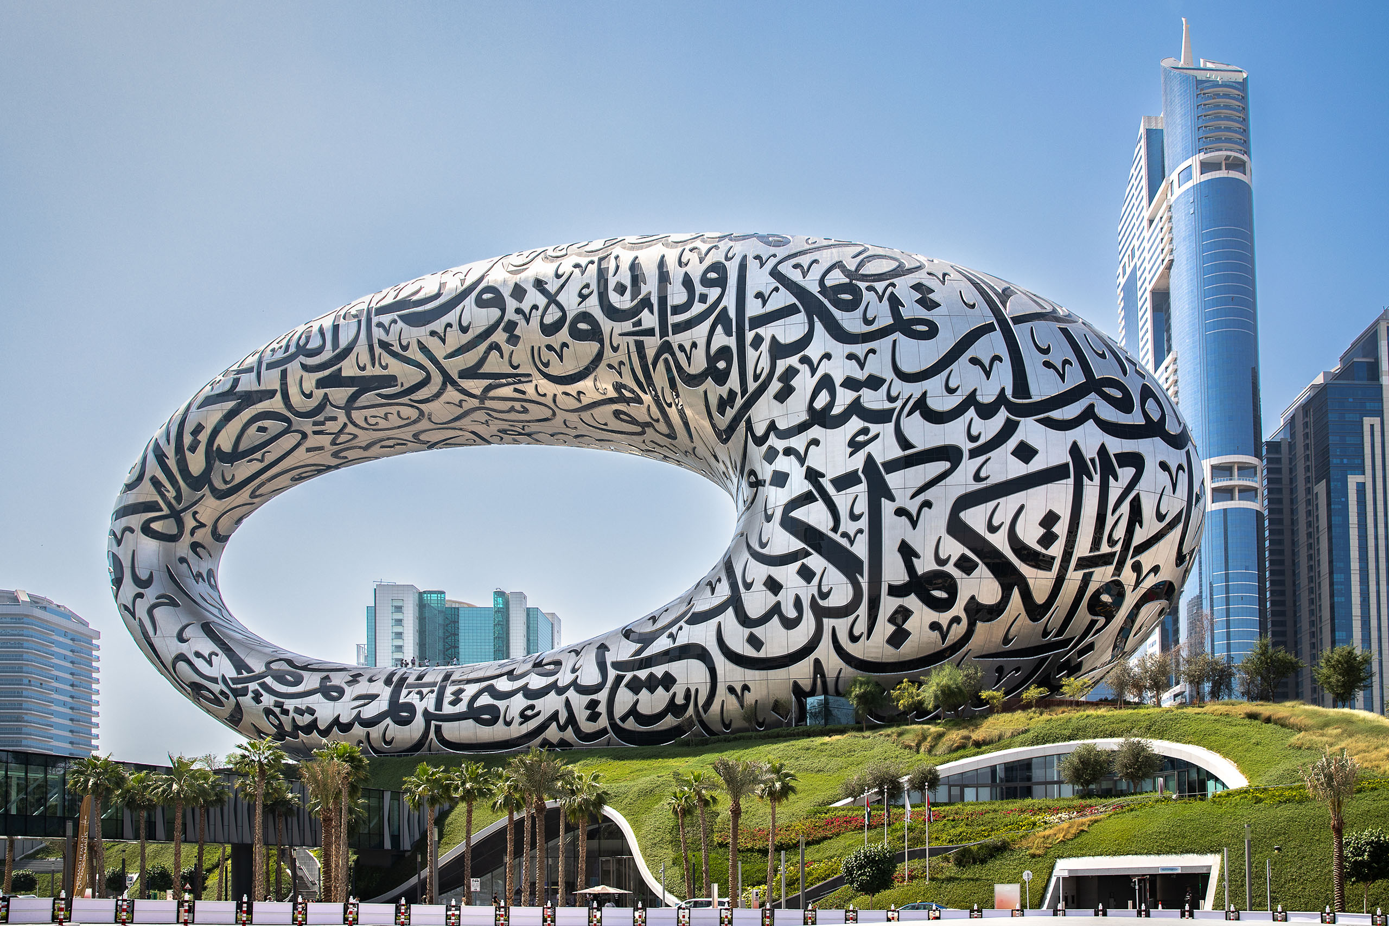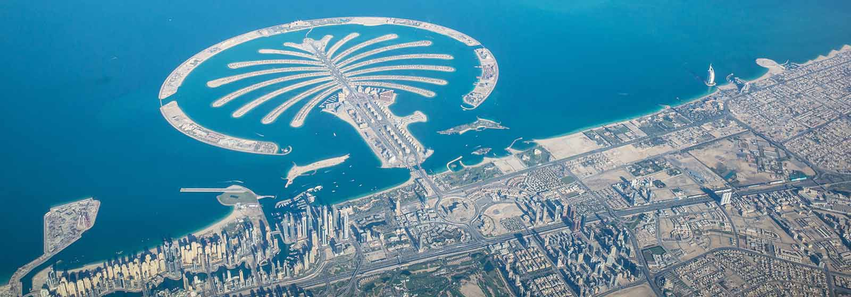
Strategic Shifts: Emiratization, Economic Diversification, and Unemployment in the UAE
Group 1E

ABSTRACT
The United Arab Emirates (UAE), situated in West Asia within the Middle East, has witnessed remarkable economic growth in the post-COVID-19 era. In particular, the country grew at a rate of 4.36% in 2021 and an even better 7.85% in 2022. Projections indicate a continued steady growth trajectory, with an anticipated rate exceeding 3% per annum until 2028. This report delves into a critical aspect of the UAE's economic landscape—its notably low unemployment rate, averaging around 3% post-COVID-19. Concurrently, it addresses a looming challenge: the country's high reliance on fiscal and external revenues derived from hydrocarbons, which raises sustainability concerns over the long term. The UAE's economic vitality hinges significantly on hydrocarbon-related activities as primary sources of income and economic expansion. However, with the global shift towards decarbonization, the UAE confronts the dual challenge of diminishing dependence on hydrocarbons and aligning its economic and policy frameworks, including fiscal policies, with climate considerations. Our report underscores the imperative for diversification, sustainable energy transition, and the cultivation of a knowledge-based economy. These measures are deemed crucial to fortify the UAE's ongoing prosperity amid evolving global economic trends and heightened environmental considerations. Despite having the most diverse economy in the Gulf Cooperation Council (GCC), the United Arab Emirates (UAE) still heavily depends on oil. With the exception of Dubai, the majority of the UAE's regions still rely significantly on oil income. Natural gas and petroleum still play major roles in the economy of the country, especially in Abu Dhabi. The United Arab Emirates (UAE) are still largely dependent on oil even though their economy is the most diverse in the Gulf Cooperation Council (GCC). With the exception of Dubai, most of the UAE's regions still heavily rely on oil revenue.

INTRODUCTION
Located between Oman and Saudi Arabia, the United Arab Emirates is bordered by the Gulf of Oman and the Persian Gulf in both the Middle East and West Asia. It is situated in a key spot in the northern approaches to the Strait of Hormuz, which is an essential crude oil transit route worldwide. The United Arab Emirates (UAE) is a federation made up of the following seven monarchies: Fujairah, Ras al-Khaimah, Sharjah, Abu Dhabi, Ajman, Dubai, and Umm al-Quwain. Founded in December 1971, the United Arab Emirates is a federation governed by a constitution. The United Arab Emirates is a federation of absolute monarchies, and its federal presidential elective constitutional monarchy serves as the basis for its politics. Since their merger in 1971, the United Arab Emirates (UAE) have experienced a notable economic development. The United Arab Emirates (UAE) has transformed from a collection of sparsely populated desert emirates to a dynamic, diversified economy with a major worldwide footprint. Oil and natural gas production, which make up the majority of the nation's enormous hydrocarbon reserves, have been a major force behind this amazing development.

Unemployment in the UAE: A Paradox amidst Economic Growth
Despite its remarkable economic growth and development, the UAE has managed to maintain a low unemployment rate. In recent years, the UAE's unemployment rate has hovered around 2-3%, significantly lower than the global average of 5.6%. This low unemployment rate is attributed to several factors, including:
Skilled Workforce Development: The UAE has heavily invested in education and skills development, ensuring that its workforce is equipped with the necessary skills to meet the demands of the diversified economy.
Pro-Business Environment: The UAE has created a pro-business environment that attracts foreign investment and encourages entrepreneurship, fostering job creation across various industries.
Government Initiatives: In order to encourage employment, the UAE government has put in place a number of initiatives, such as support for small and medium-sized businesses (SMEs), job placement services, and training programmes.
However, the UAE's low unemployment rate does not imply a complete absence of employment challenges. Certain sectors, such as construction and retail, have experienced periods of higher unemployment due to economic fluctuations and changing consumer trends. Additionally, the UAE's rapidly growing population may put pressure on job creation in the future. The young emirates have a very high rate of unemployment due to high reliance on public sector jobs and low skilled labor.
The UAE's success in maintaining low unemployment amidst economic growth is a testament to its strategic approach to economic development and its focus on human capital development. As the country continues to diversify its economy and embrace new technologies, it is well-positioned to maintain a strong and resilient labor market in the years to come.
The UAE's unemployment rate displayed varying trends between 2018 and 2022. Starting at 2.24% in 2018, it saw a slight increase to 2.33% in 2019. Notably, 2020 experienced a spike to 4.29%, followed by a recovery in 2021 with a rate of 3.11%. The positive trend continued into 2022, showcasing a decline to 2.75%, indicative of the nation efforts to maintain employment stability amid changing economic landscape.
Hydrocarbons as the Cornerstone of the UAE Economy
Hydrocarbons have played a pivotal role in shaping the UAE's economic trajectory. The discovery of oil in Abu Dhabi in 1958 marked the beginning of an era of unprecedented wealth and development. Oil and gas production quickly became the backbone of the UAE economy, generating substantial fiscal revenue that fueled infrastructure development, social welfare programs, and economic diversification initiatives.
The UAE's reliance on hydrocarbons is evident in both its fiscal and external revenue streams. Oil and gas revenues account for a significant portion of the UAE's government budget, providing funding for essential public services, infrastructure projects, and social welfare programs.
Additionally, hydrocarbon exports constitute a major component of the UAE's external trade, generating foreign exchange earnings that support the country's import needs and economic growth.
The UAE economy is heavily dependent on external and fiscal revenue from hydrocarbons, primarily oil and gas. The following explains the dependency on the hydrocarbon sector:
- Primary GDP Contributor- Hydrocarbons contribute 30% to the UAE's GDP, making the oil and gas industry the primary driver of economic output.
- Major Export Revenue- Approximately 13% of the UAE's exports come from the oil and gas sector, indicating a significant reliance on hydrocarbons for international trade revenue.
- Government Revenue Source- The sale of hydrocarbons serves as a major source of fiscal revenue for the UAE government, funding public services and infrastructure projects.
- Foreign Exchange Earnings- Hydrocarbon exports generate substantial foreign exchange earnings, supporting the stability of the UAE's currency and overall economic resilience.
- Investment and Economic Development- Revenues from the oil and gas industry are often reinvested in non-oil sectors, playing a pivotal role in financing economic diversification and development initiatives.
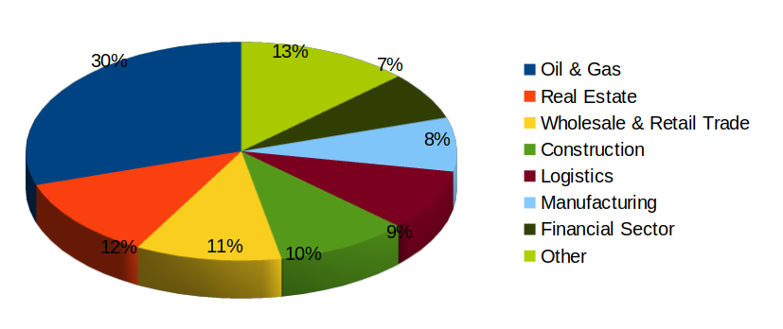
According to the UAE country commercial guide published by the International Trade Administration, 13% of the nation's exports and 30% of the country's GDP are directly related to the oil and gas industry, indicating the continued importance of the hydrocarbon sector to the UAE's economy.
However, the country is facing some challenges due to this high dependence:
- Hydrocarbons are crucial to the United Arab Emirates' (UAE) economic expansion and government revenue. The unpredictability of the world oil price is therefore a threat to the UAE. The UAE's fiscal revenue decreases with a drop in oil prices, which may result in reductions to state spending. Public employment may be strained and non-oil sector growth may be slowed as a result.
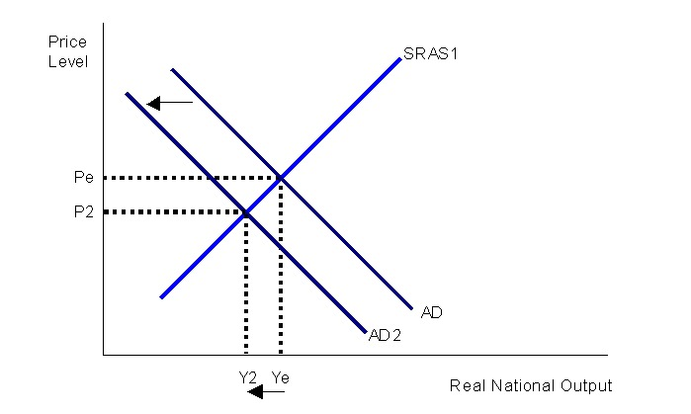
Due to a drop in oil prices, government revenue decreases, leading to a reduction in government spending. This contractionary fiscal policy causes the aggregate demand curve to shift to the left.

(ii) Energy shifts have an immediate effect on Arab states. These economies are the most dependent on hydrocarbon rents (in the form of export earnings in exporting nations and foreign remittances in importing economies from citizens working in exporting states) and are home to some of the greatest global reserves. As a result, the area has long faced an existential danger from the decline in the world market for hydrocarbons, particularly the wealthy Gulf Cooperation Council (GCC) governments of Bahrain, Kuwait, Oman, Qatar, Saudi Arabia, and the United Arab Emirates.
(iii) The primary cause of the GCC's incapacity to fully diversify is the reliance of the majority of these nations' non-oil investment initiatives on oil earnings. The GCC nations are currently in the process of changing their respective traditional economic structures, which place a heavy emphasis on oil and gas as the primary sources of government revenue and GDP. This portion must be replaced by non-oil economic sectors that may greatly boost economic growth and government revenue but are not reliant on the hydrocarbon sector, either directly or indirectly, for economies to be deemed diversified.

Macroeconomic Indicators
The macroeconomic indicators of the United Arab Emirates (UAE) provide a comprehensive overview of the nation's economic health and performance. Marked by a robust and diversifying economy, the UAE demonstrates resilience and adaptability amidst evolving global economic landscapes. With a focus on stable GDP growth, low inflation rates, and a relatively low unemployment rate, the UAE has positioned itself as a regional economic powerhouse. The country's fiscal policies, trade openness, and strategic investments in key sectors contribute to its economic vibrancy. Additionally, the UAE's prudent management of public finances and efforts towards economic diversification underscore its commitment to long-term sustainability. As a key player in the global energy market, the UAE carefully navigates the challenges of hydrocarbon dependency, seeking to align economic strategies with emerging trends, including sustainable practices and technological advancements. Overall, the macroeconomic indicators reflect the UAE's proactive stance in fostering a resilient and adaptive economic environment.

GDP (Gross Domestic Product)
The UAE's GDP exhibited dynamic shifts from 2018 to 2022, starting at 427.05 billion with a growth rate of 1.31% and experiencing fluctuations, including a dip to 349.47 billion in 2020 with a -4.96% growth rate. Notably, 2021 marked a resurgence with a GDP of 507.06 billion and a growth rate of 4.36%, followed by a robust growth of 7.85% in 2022, reaching 509.18 billion. Projections indicate a continued upward trajectory, with the GDP expected to reach 618 billion by 2028, reflecting the UAE's resilient economic outlook and strategic growth initiatives.
Year | GDP (In U.S. dollars) | Growth Rate
2018 | 427.08 bn | 1.31%
2019 | 417.99 bn | 1.11%
2020 | 349.47 bn | -4.96%
2021 | 507.06 bn | 4.36%
2022 | 509.18 bn | 7.85%

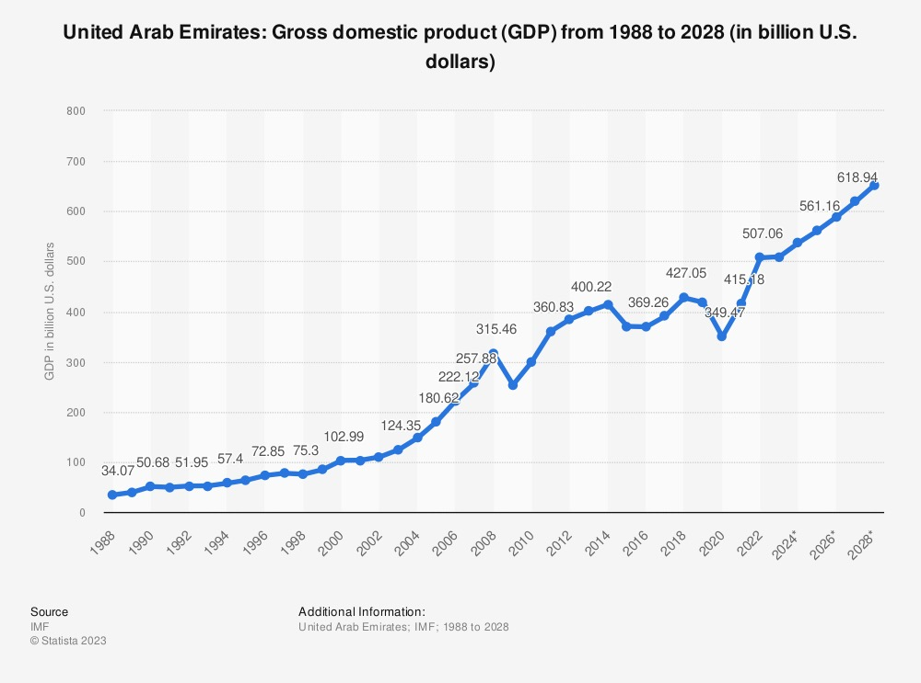

GDP per capita
The GDP per capita in the United Arab Emirates witnessed fluctuations between 2018 and 2022, starting at 45,591.68 USD in 2018 and dipping to 37,648.96 USD in 2020. Notably, there was a resurgence in 2021, reaching 43,438.52 USD, followed by a substantial increase to 51,399.96 USD in 2022. These figures reflect both the impact of global economic trends and the resilience of the UAE's economic landscape, resulting in a notable rise in GDP per capita over the specified period.
Year | GDP per capita (In US Dollars)
2018 | 45591.68
2019 | 43981.61
2020 | 37648.96
2021 | 43438.52
2022 | 51399.96

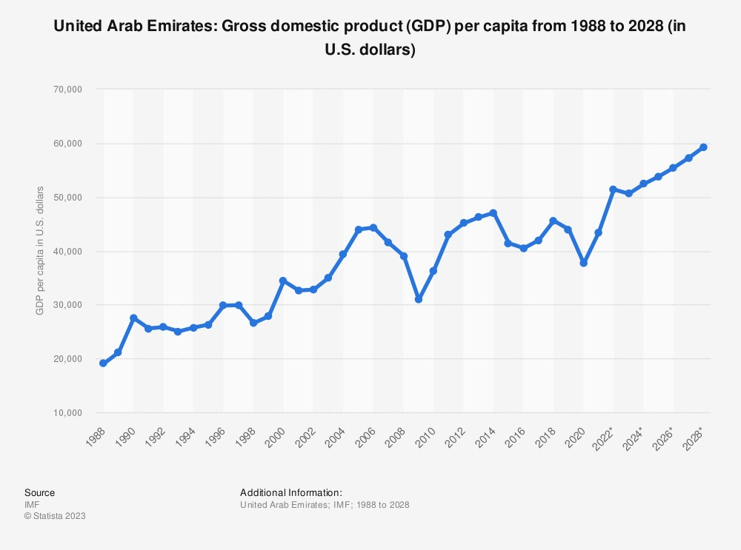
Inflation Rate
The UAE's inflation rate exhibited contrasting trends from 2018 to 2022. Beginning at 3.07% in 2018, the subsequent years saw deflation, with rates of -1.93% in 2019 and -2.08% in 2020. However, a reversal occurred in 2022, marking a notable inflation of 4.83%. This dataset highlights the economic dynamics and policy influences contributing to the inflationary and deflationary phases experienced by the UAE during the specified period.

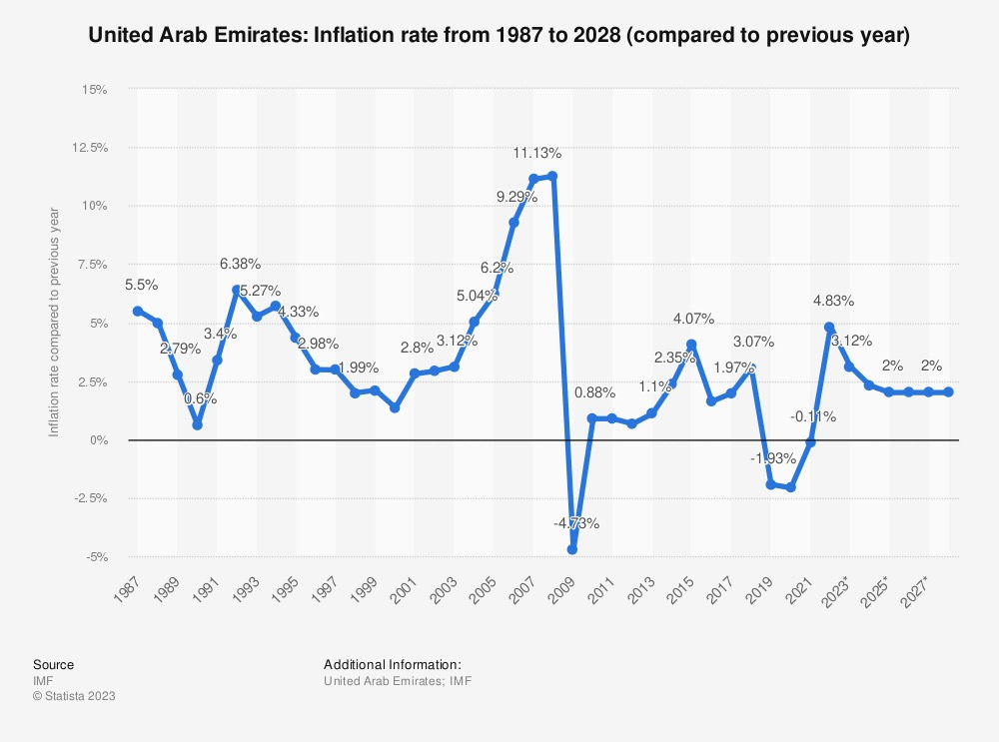

OBJECTIVES
The growth of the UAE's economy in the wake of the COVID-19 pandemic, its low unemployment rate, and its reliance on hydrocarbons are the focal points of this study. An analysis of the nation's economic robustness and the imperative for diversification in light of worldwide patterns toward sustainability and technological progress is detailed in the report. Macroeconomic indicators, patterns of unemployment, and hydrocarbons are analyzed in order to comprehend the UAE's economic development. In addition, emiratisation and long-term economic objectives are assessed, along with potential remedies for unemployment and reliance on petroleum. The primary objectives are to generate long-term growth and adaptation strategies and to comprehend the economic dynamics of the UAE.

EVOLUTION AND KEY DEVELOPMENTS
Unemployment
The UAE's effective management of low unemployment rates amid economic expansion underscores its strategic approach to economic development and prioritization of human capital growth. The nation has consistently sustained a stable low unemployment rate but facing many issues:
High Youth Unemployment rate - Even while the proportion of young people enrolling in postsecondary education has increased, young people in the UAE—like those in other Middle Eastern countries—frequently struggle to make the transition from school to the workforce. Previous studies have demonstrated that young Emiratis' internship programmes did not necessarily lead to actual job placements. The main cause of the rise in Arab unemployment rates is the large and ongoing influx of young Arab workers into the labour market each year, which Arab economies are unable to accommodate with enough job openings. Stated differently, there is a greater supply of labour than there is demand for it. The Arab region's youth unemployment rate will persist until 2040 if current rates of growth and employment hold steady.
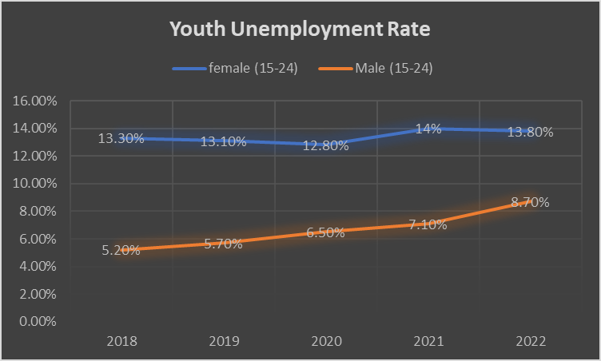
The inclination of young UAE nationals for positions in the public sector is a significant contributing reason to the high rate of unemployment among this demographic. Emiratis used to only work for the government, and this attitude hinders them from looking for respectable positions in private companies. The UAE's superior perks and compensation packages are the main reasons for these inclinations for public sector employment over private sector positions. Compared to the private sector, public sector employment is safer, more lucrative, and less demanding in terms of working hours and accountability. However, due to limited government resources, the government is unable to continue employing recent graduates for positions in the public sector at the rate of population growth. A person frequently needs "wasta" (intercession or influence) to land one of these jobs because there is fierce competition for them. Employers want seasoned professionals with strong leadership and communication abilities, even when the private sector offers less appealing packages. Furthermore, the young Emiratis' aptitudes, competencies, and lifestyles frequently do not align with the quickly changing fields of the UAE knowledge economy. This contributes to the relatively high unemployment rates. Furthermore, when compared to their colleagues who are foreigners, young Emiratis have relatively little work experience. The notion of taking jobs, particularly low-paying ones, while still in high school or college is not very well-liked by Emiratis because their families do not encourage it. The issue of not having any job experience—which is often requested by employers—was brought up by university graduates. In spite of this, young Emiratis frequently exhibit a lack of commitment to their employers and have inflated expectations for their job titles, working hours, and pay.

Dependence on Hydrocarbons
The discovery of oil in the 1960s transformed the UAE's economy, accelerating development. The country diversified, with Dubai becoming a global hub, to avoid oil dependency. Government actions helped the UAE recover from the 2008 financial crisis. Recent efforts include renewable energy investments for sustainable development. Oil is vital, but the UAE actively diversifies its economy for a resilient and inventive future. However, the country still depends heavily on the sector of hydrocarbon contributing close to 30% of its GDP. As such, the country is continuing to face the various challenges in terms of this dependency:
- Energy transitions have a direct impact on Arab states. These regions harbour a considerable portion of the most substantial reserves of hydrocarbon globally and have the most overdependent economies on hydrocarbon rents, which importing economies receive as foreign remittances from nationals employed in exporting states and export revenue in exporting economies. Therefore, the region has long been confronted with an existential peril due to the diminished worldwide demand for hydrocarbons, mainly for affluent Gulf Cooperation Council (GCC) nations that export hydrocarbons: Bahrain, Kuwait, Oman, Qatar, Saudi Arabia, and the United Arab Emirates.
- The primary factor impeding the complete diversification of the UAE economy is the reliance of its non-oil investment initiatives on oil revenues. Currently, the UAE is undergoing a process of economic restructuring away from its conventional economic framework, which primarily relies on oil and gas for government revenues and total GDP. To qualify as a diversified economy, this proportion must be substituted with non-oil economic sectors that do not rely on the hydrocarbon sector either directly or indirectly. Such sectors have the potential to make substantial contributions to both government revenue and economic expansion.

ANALYSIS OF MACROECONOMIC SITUATION AND POLICY INTERVENTION
Unemployment & Emiratisation
Emiratisation is a government initiative in the United Arab Emirates (UAE) to employ its citizens in the public and private sectors. The government's goal is to increase the number of Emiratis working in the private sector.
The Emiratisation rules for the private sector are:
- 50 or fewer employees: 1 Emirati
- 51–100 employees: 2 Emiratis
- The government also requires companies to increase the proportion of Emirati employees by 1% every six months
Emiratisation is helping to: Create new jobs and businesses, Diversify the UAE's economy and
create new opportunities for growth.
The PwC Middle East - Emiratisation Survey 2023 highlights Emirati workers' strong satisfaction with the public sector, attributing it to competitive compensation, job security, and positive perceptions of learning and development opportunities. Conversely, Emiratis in the private sector face challenges, with 50% citing work-life balance issues and lower satisfaction with compensation. The survey indicates a 20% satisfaction gap between private and public sectors, leading two-thirds of private-sector employees to consider returning to the public sector. Overall, compensation and career growth significantly influence Emiratis' job preferences in both sectors.
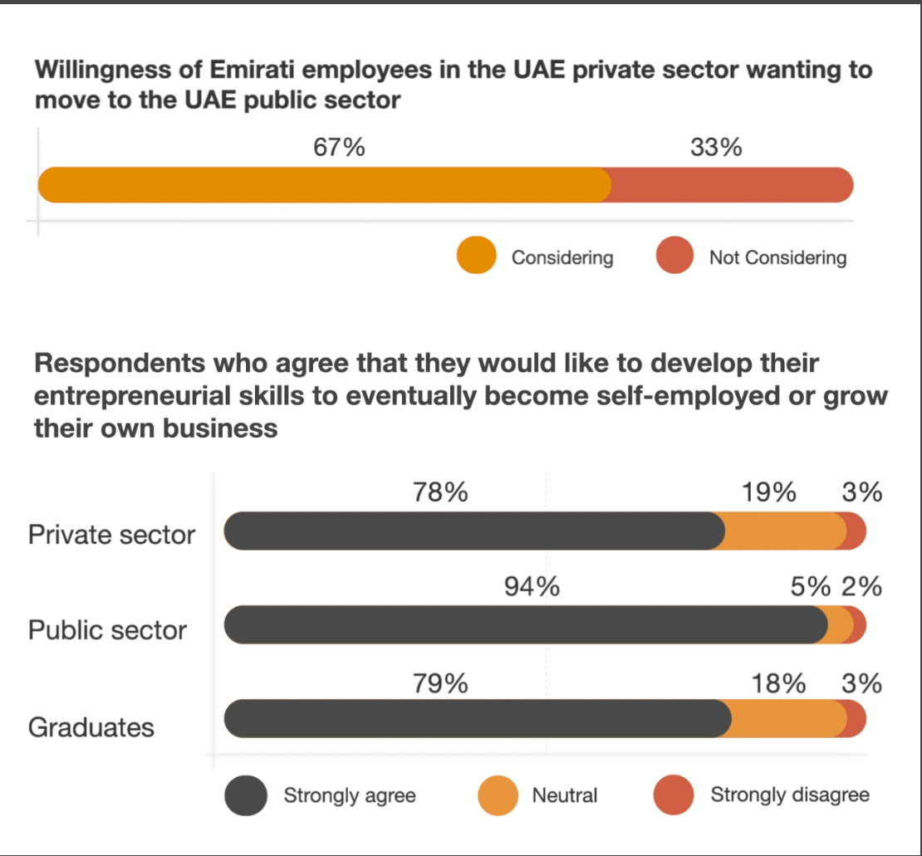
The UAE's economy heavily relies on expatriate workers, constituting 89% of the population and 92% of the workforce, with only 4% of employees in the private sector being Emiratis. Traditionally, Emiratis favor the public sector for its perceived rewards, job flexibility, and aligned values. However, with the economy set to grow and diversify, there is an urgent need to reduce dependence on the public sector and invest in developing skills among the youth. The private sector must actively participate in attracting, retaining, and cultivating Emirati talent to support the country's transformation into a green, digital, and knowledge-based economy.
Emiratis employed in UAE private sector face work-life balance challenges
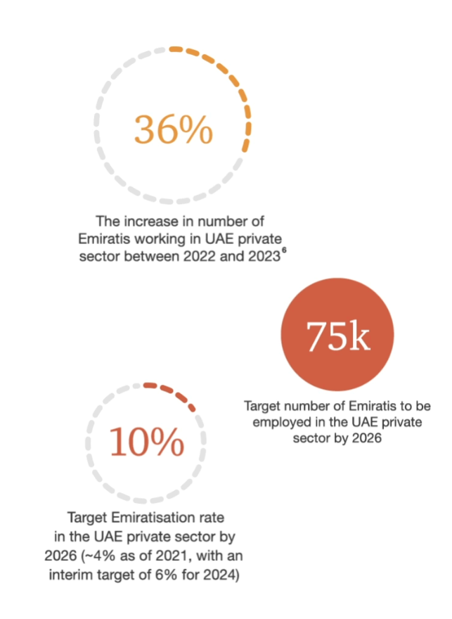

Abu Dhabi Economic Vision 2030 and Dubai Strategic Plan 2015
Leading the charge to attain diversification are Dubai's Strategic Plan 2015 and Abu Dhabi's Economic Vision 2030. Investment in industrial and export-oriented sectors—which include heavy industry, transportation, petrochemicals, tourism, information technology, telecommunications, renewable energy, aviation and space, and oil and gas services—must be increased. Many fields have seen significant advancements, most notably renewable energy, the aviation sector, and satellite and telecommunications. The long-term strategy has not changed, even though the immediate priorities have been modified to account for changing conditions.

UAE Vision 2021
The UAE is actively pursuing its 2021 Vision at the federal level. This vision intends to establish a knowledge-based, highly productive, and competitive economy by the time of the federation's golden jubilee in 2021, with a strong emphasis on innovation, research, science, and technology. The younger generation plays a major part in this progressive agenda, assuming crucial leadership positions in several domains such as industry, government, and research. Arab youngsters are progressively regarding the UAE as the foremost country to reside in, mostly due to its extensive range of employment prospects.

Tourism
A major factor in the achievement of economic diversification has been tourism. In terms of visitors, 2014 was the best year ever for Abu Dhabi's 156 hotels; visitors to Dubai's 634 businesses have also increased significantly. Emiratis elsewhere are doing the same. The two top airlines in the United Arab Emirates, Etihad and Emirates, along with ongoing improvements to the aviation infrastructure, have significantly advanced the travel and tourist sector and are important drivers of the national economy.

RECOMMENDATIONS AND CONCLUSION
For countering the high unemployment rate among young emirates, the government can bring “Diversified sourcing strategies” - This entails forming alliances with academic institutions to jointly develop curricula that align with future-ready skills; ensuring that high-achieving participants receive job offers upon graduation; organising career fairs and awareness sessions at educational institutions; initiating talent exchange and secondment programmes for citizens working in the public sector; and utilising nationalization-specific job-matching platforms to increase the visibility of job openings for job seekers.
For reducing the dependence on hydrocarbon revenue, the government needs to:
“Invest in renewable energy” - The UAE is one of the sunniest countries in the world, so it has a lot of potential for solar energy. The government should invest in renewable energy projects and provide incentives for businesses and individuals to switch to renewable energy sources.
“Diversify the economy” - The UAE has already made significant progress in diversifying its economy, but there is still more that can be done. The government should focus on developing non-oil sectors such as tourism, finance, and technology. It should also invest in infrastructure and education to support these sectors.
Conclusively, the United Arab Emirates (UAE) has exhibited exceptional economic expansion following the COVID-19 pandemic, with a 7.85% rise in GDP in 2022. However, the report emphasizes the country's substantial reliance on hydrocarbons, which account for 30% of its GDP. The UAE's exceptionally low unemployment rate, which hovers around 3%, is a clear indication of its astute expenditures in education and a favorable business climate. Nevertheless, there are still obstacles that remain, particularly in regards to the issue of youth unemployment and the imperative to shift away from hydrocarbons. The paper highlights the significance of transitioning to renewable energy, diversifying the economy, and fostering a knowledge-based economy. The UAE's proactive stance towards these problems, as delineated in projects such as Emiratisation and long-term economic plans, situates the country for ongoing resilience and triumph in the face of changing global economic patterns.

REFERENCES AND SOURCES
- https://www.statista.com/topics/2703/united-arab-emirates/#topicOverview
- https://www.bbc.com/news/world-middle-east-14703998
- https://unitearabemirateseconomics.weebly.com/unemployment.html
- https://ivypanda.com/essays/unemployment-in-abu-dhabi-and-dubai-causes-and-solutions/
- Gonzalez, G., Karoly, L. A., Constant, L., Goldman, C. A., & Salem, H. (2018). Facing human capital challenges of the 21st century: Education and labor market initiatives in Lebanon, Oman, Qatar, and the United Arab Emirates (Vol. 786). Chapter 4.
- Poplavskaya, A., Karabchuk, T., Shomotova, A. (2023). Unemployment Challenge and Labor Market Participation of Arab Gulf Youth: A Case Study of the UAE. In: Rahman, M.M., Al-Azm, A. (eds) Social Change in the Gulf Region. Gulf Studies, vol 8. Springer, Singapore
- Sultana, R. G. (2014). Livelihood planning and career guidance in Palestine and the broader MENA region. International Review of Education, 60(2), 177–197
- World Economic Forum. (2014). Rethinking Arab employment: A systemic approach for resource-endowed economies
- Abdelgadir, S. (2020). Challenges and potentiality of GCC countries towards achieving sustainable economic growth: Analytical framework. European Journal of Business and Innovation Research, 8(5), 23–37
- Ahmed, O. S. (2003). Assessing relevance of work placement schemes of higher education institutes in the UAE. CLMRI, National Human Resource Development and Employment Authority, Careers, Skills, and Training Survey Series №3, Dubai, UAE: CLMRI
- Mina, W. (2021). Youth Unemployment and Productivity-Pay in the GCC Countries
- https://carnegieendowment.org/2023/05/03/hurdles-of-energy-transitions-in-arab-states-pub-89518
- https://www.pwc.com/m1/en/publications/emiratisation-survey-2023-the-retention-riddle.html
- https://www.mofa.gov.ae/en/Missions/Paris/The-UAE/UAE-Economy#:~:text=Diversification%20Creates%20Trade%20Opportunities&text=The%20strategy%20is%20to%20increase,and%20oil%20and%20gas%20services
- Kabbani, N., & Ben Mimoune, N. (2021). Economic diversification in the Gulf: Time to redouble efforts. Brookings Doha Center, Briefing Policy, January, Doha, Qatarkabbani
- Miniaoui, H. (Ed.). (2020). Economic development in the Gulf cooperation council countries: From rentier states to diversified economies (Vol. 1). Springer Nature
- International Monetary Fund (2023). United Arab Emirates: 2022 Article IV Consultation-Press Release; and Staff Report. IMF Country Reports, 23/223

THANK YOU

Team Members

Anirban Roy | 2023PGP005
Ayesha Fatima | 2023PGP017
Himanshu Dixit | 2023PGP025
Mahima Barate | 2023PGP035
Mayank Sharma | 2023PGP036
Soumee Guha | 2023PGP059
Vartika Razathani | 2023PGP067

